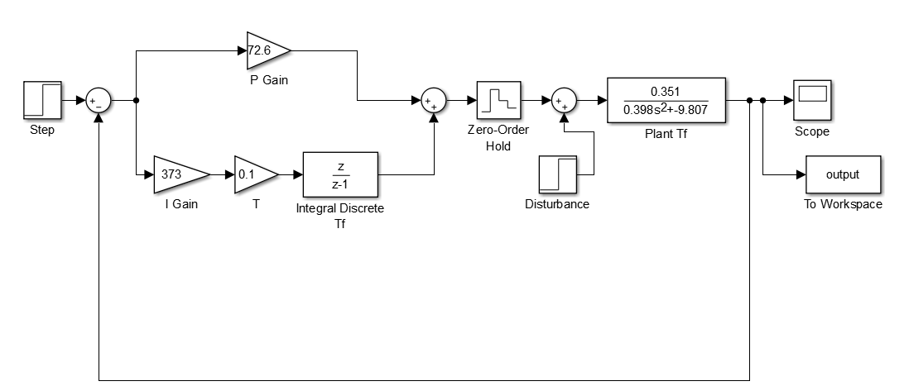

PI controller discretised by backward rule.



Two degree of freedom controller

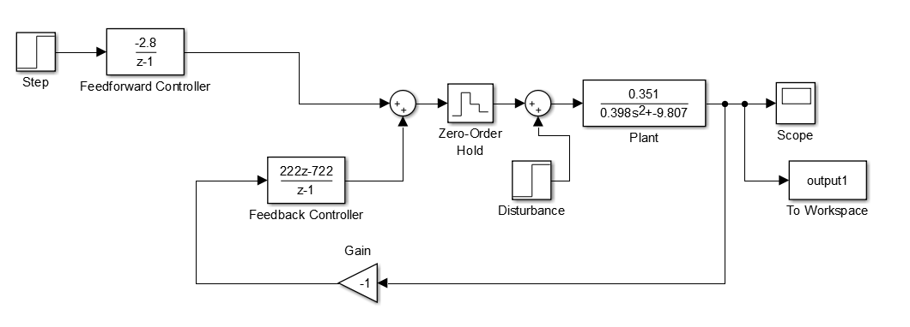



**Discretisation of transfer functions:**

sys=tf([0.357],[0.398,0, -9.807])

sys1= c2d (sys, 0.1)

Discrete-time transfer function: (0.004578 z + 0.004578) / ( z^2 - 2.252 z + 1)

Sample time: 0.1 seconds

sys2=tf([5.43],[1,4,5.43])

sys3= c2d (sys2, 0.1)

Discrete-time transfer function: (0.02376 z + 0.02079) / (z^2 - 1.626 z + 0.6703)Sample time: 0.1 seconds